Operations Management, 10e, Global Edition (Heizer/Render)
Chapter 14 Material Requirements Planning (MRP) and ERP

1) Wheeled Coach obtains competitive advantage through MRP in part because of their excellent record integrity and insistence on record accuracy.
Answer: TRUE
Diff: 1
Topic: Global company profile
Objective: no LO

2) MRP is generally practiced on items with dependent demand.
Answer: TRUE
Diff: 1
Topic: Dependent demand
Objective: no LO

3) Reduced inventory levels and faster response to market changes are both benefits of MRP.
Answer: TRUE
Diff: 1
Topic: Dependent demand
Objective: no LO

4) A dependent demand item is so called because its demand is dependent on customer preferences.
Answer: FALSE
Diff: 2
Topic: Dependent demand
Objective: no LO

5) The quantity required of a dependent demand item is computed from the demand for the final products in which the item is used.
Answer: TRUE
Diff: 2
Topic: Dependent demand
Objective: no LO

6) Since MRP is quite detailed in nature, it has no influence on the longer-range, less detailed aggregate planning.
Answer: FALSE
Diff: 2
Topic: Dependent inventory model requirements
Objective: no LO

7) The master production schedule is a forecast of demand for families of products.
Answer: FALSE
Diff: 1
Topic: Dependent inventory model requirements
Objective: no LO
8) Lead times, inventory availability, and purchase orders outstanding are among the five things operations managers must know for effective use of MRP.
Answer: TRUE
Diff: 1
Topic: Dependent inventory model requirements
Objective: LO14-2

9) A bill of material lists all components, ingredients, and materials needed to produce one unit of an end item.
Answer: TRUE
Diff: 2
Topic: Dependent inventory model requirements
Objective: LO14-1

10) "Phantom bills" are bills of material for subassemblies that do not exist in reality.
Answer: FALSE
Diff: 1
Topic: Dependent inventory model requirements
Objective: LO14-1

11) Planning bills of material are bills of material for "kits" of inexpensive items such as washers, nuts, and bolts.
Answer: TRUE
Diff: 2
Topic: Dependent inventory model requirements
Objective: LO14-1

12) The Aggregate Plan, derived from the Master Production Schedule, specifies in more detail how much of which products is to be made at what times.
Answer: FALSE
Diff: 2
Topic: Dependent inventory model requirements
Objective: LO14-2

13) The time-phased product structure, unlike the bill of material, adds the concept of lead times.
Answer: TRUE
Diff: 2
Topic: Dependent inventory model requirements
Objective: LO14-1

14) If X consists of one A and one B, and each A consists of one F and two Gs, then A is the "parent" component of G.
Answer: TRUE
Diff: 2
Topic: Dependent inventory model requirements
Objective: LO14-1
15) If 100 units of Q are needed and 10 are already in stock, then the gross requirement is 100 and the net requirement is 90.
Answer: TRUE
Diff: 1
Topic: MRP structure
Objective: LO14-3

16) Gross material requirements do not take into account the amount of inventory on hand.
Answer: TRUE
Diff: 1
Topic: MRP structure
Objective: LO14-2

17) In MRP, a "bucket" refers to a fixed order quantity, such as an EOQ.
Answer: FALSE
Diff: 2
Topic: MRP management
Objective: LO14-2

18) Time fences divide that segment of the MPS that can be revised from that section that is "frozen."
Answer: TRUE
Diff: 1
Topic: MRP management
Objective: LO14-2

19) MRP is an excellent tool for scheduling products with variable lead times.
Answer: FALSE
Diff: 1
Topic: MRP management
Objective: LO14-2

20) Finite capacity scheduling, unlike MRP, recognizes the capacity limitations of departments and machines when building schedules.
Answer: TRUE
Diff: 1
Topic: MRP management
Objective: LO14-2

21) If parts and subassemblies common to a variety of products are managed through the supermarket concept, formal order releases for such parts are not necessary.
Answer: TRUE
Diff: 1
Topic: MRP management
Objective: LO14-2
22) The lot-for-lot lot-sizing technique is particularly appropriate when demand is not very smooth and set up cost is small compared to holding cost.
Answer: TRUE
Diff: 2
Topic: Lot-sizing techniques
Objective: LO14-4
23) In general, the lot-for-lot approach should be used whenever economical.
Answer: TRUE
Diff: 2
Topic: Lot-sizing techniques
Objective: LO14-4

24) The economic part period is a fraction of a time bucket.
Answer: FALSE
Diff: 1
Topic: Lot-sizing techniques
Objective: LO14-4

25) The Wagner-Whitin algorithm is the most widely used MRP lot-sizing technique.
Answer: FALSE
Diff: 2
Topic: Lot-sizing techniques
Objective: LO14-4

26) MRP can be effective only if very accurate lot sizes are calculated in advance.
Answer: FALSE
Diff: 1
Topic: Lot-sizing techniques
Objective: LO14-4

27) Smoothing a resource requirements profile to stay within capacity limits may increase setup costs.
Answer: TRUE
Diff: 2
Topic: Extensions of MRP
Objective: LO14-5

28) Closed-loop MRP systems allow production planners to move work between time periods to smooth the load or to at least bring it within capacity.
Answer: TRUE
Diff: 2
Topic: Extensions of MRP
Objective: LO14-6
29) Operations splitting sends pieces to the next operation before the entire lot is completed on the previous operation.
Answer: FALSE
Diff: 2
Topic: Extensions of MRP
Objective: LO14-6

30) When safety stock is deemed absolutely necessary, the usual policy is to build it into the projected on-hand inventory of the MRP logic.
Answer: TRUE
Diff: 2
Topic: MRP structure
Objective: LO14-2

31) By convention, the top level in a bill of material is designated level 1.
Answer: FALSE
Diff: 2
Topic: Dependent inventory model requirements
Objective: no LO

32) DRP is a time-phased stock-replenishment plan for all levels of a distribution network.
Answer: TRUE
Diff: 2
Topic: MRP in services
Objective: no LO

33) While ERP may provide a strategic advantage over competitors, it is so complex that many companies cannot adjust to it.
Answer: TRUE
Diff: 2
Topic: Enterprise resource planning (ERP)
Objective: LO14-7

34) Firms may discover that, rather than adapting ERP to the way they do business, they have to adapt the way they do business to accommodate the ERP software.
Answer: TRUE
Diff: 2
Topic: Enterprise resource planning (ERP)
Objective: LO14-7

35) The supply-chain systems that result from using ERP in the grocery industry are called efficient consumer response (ECR) systems.
Answer: TRUE
Diff: 1
Topic: Enterprise resource planning (ERP)
Objective: LO14-7
36) Which of the following statements regarding Wheeled Coach is false?
A) Wheeled Coach has found competitive advantage through MRP.
B) Wheeled Coach builds ambulances in a repetitive process.
C) Wheeled Coach's MRP system allowed the company to meet tight schedules, but caused inventory to rise.
D) Wheeled Coach's MRP system maintains excellent record integrity.
E) Low inventory and high quality are two positive outcomes of Wheeled Coach's use of MRP.
Answer: C
Diff: 1
Topic: Global company profile
Objective: no LO

37) Wheeled Coach insists all of the following tasks are key to successful MRP use except
A) materials plan must meet both schedule requirements and facility capabilities
B) plan must be executed as designed
C) inventory investment must be minimized
D) excellent record integrity must be maintained
E) stringent quality control
Answer: E
Diff: 2
Topic: Global company profile
Objective: no LO

38) Demand for a given item is said to be dependent if
A) it originates from the external customer
B) there is a deep bill of material
C) the finished products are mostly services (rather than goods)
D) there is a clearly identifiable parent
E) the item has several children
Answer: D
Diff: 1
Topic: Dependent demand
Objective: no LO

39) The phrase "demand related to the demand for other products" describes
A) a dependent variable
B) dependent demand
C) recursive demand
D) regression analysis
E) independent demand
Answer: B
Diff: 1
Topic: Dependent demand
Objective: no LO
40) Dependent demand and independent demand items differ in that
A) for any product, all components are dependent-demand items
B) the need for independent-demand items is forecast
C) the need for dependent-demand items is calculated
D) All of the above are true.
E) None of the above is true.
Answer: D
Diff: 2
Topic: Dependent demand
Objective: no LO

41) Which of the following is not a key benefit of MRP?
A) quality increases
B) better response times to customer orders
C) faster response to market changes
D) improved utilization of facilities
E) reduced inventory levels
Answer: A
Diff: 2
Topic: Dependent demand
Objective: no LO

42) Effective use of MRP and other dependent demand models does not require which of the following?
A) master production schedule
B) bill of materials
C) inventory availability
D) lead times
E) cost of individual components
Answer: E
Diff: 2
Topic: Dependent inventory model requirements
Objective: no LO

43) A master production schedule specifies
A) the raw materials required to complete the product
B) what component is to be made, and when
C) what product is to be made, and when
D) the labor hours required for production
E) the financial resources required for production
Answer: C
Diff: 2
Topic: Dependent inventory model requirements
Objective: LO14-2
44) The __________ is (are) the MRP input detailing which end items are to be produced, when they are needed, and in what quantities.
A) master production schedule
B) gross requirements
C) inventory records
D) assembly time chart
E) bill of material
Answer: A
Diff: 2
Topic: Dependent inventory model requirements
Objective: LO14-2

45) A master production schedule contains information about
A) quantities and required delivery dates of all subassemblies
B) quantities and required delivery dates of final products
C) inventory on hand for each subassembly
D) inventory on hand for each final product
E) scheduled receipts for each final product
Answer: B
Diff: 2
Topic: Dependent inventory model requirements
Objective: LO14-2

46) The aggregate plan gets input or feedback from which of the following areas?
A) engineering
B) finance, marketing, and human resources
C) the master production schedule
D) procurement, production, and general management
E) all of the above
Answer: E
Diff: 1
Topic: Dependent inventory model requirements
Objective: no LO

47) Which portion of the master production schedule is normally fixed, frozen, or firm?
A) the entire schedule
B) only the aggregate schedule
C) only the middle of the schedule
D) only the near-term portion
E) only the far-term portion
Answer: D
Diff: 2
Topic: Dependent inventory model requirements
Objective: LO14-2
48) In continuous (make-to-stock) operations, the master production schedule is usually expressed in terms of
A) end items
B) modules
C) kits
D) customer orders
E) warehouse orders
Answer: A
Diff: 2
Topic: Dependent inventory model requirements
Objective: LO14-2

49) In job shop (make-to-order) operations, the master production schedule is usually expressed in
A) end items
B) modules
C) kits
D) customer orders
E) warehouse orders
Answer: D
Diff: 2
Topic: Dependent inventory model requirements
Objective: LO14-2

50) The following table is an example of a(n)

 | Week 1 | Week 2 | Week 3 | Week 4 | Week 5
Clothes Washer |  | 200 |  | 100
Clothes Dryer | 300 | 100 | 100 |  | 100
Upright Freezer |  |  | 200 | 500

A) aggregate plan
B) load report
C) master production schedule
D) capacity plan
E) inventory record
Answer: C
Diff: 2
Topic: Dependent inventory model requirements
Objective: LO14-2
51) A document calls for the production of 50 small garden tractors in week 1; 50 small garden tractors and 100 riding mowers in week 2; 100 riding mowers and 200 garden utility carts in week 3; and 100 riding mowers in week 4. This document is most likely a(n)
A) net requirements document
B) resource requirements profile
C) aggregate plan
D) master production schedule
E) Wagner-Whitin finite capacity document
Answer: D
Diff: 2
Topic: Dependent inventory model requirements
Objective: LO14-2

52) The __________ is the input to material requirements planning which lists the assemblies, subassemblies, parts, and raw materials needed to produce one unit of finished product.
A) bill of material
B) master production schedule
C) inventory records
D) assembly time chart
E) net requirements chart
Answer: A
Diff: 2
Topic: Dependent inventory model requirements
Objective: LO14-1

53) A bill of material lists the
A) times needed to perform all phases of production
B) production schedules for all products
C) components, ingredients, and materials required to produce an item
D) operations required to produce an item
E) components, ingredients, materials, and assembly operations required to produce an item
Answer: C
Diff: 2
Topic: Dependent inventory model requirements
Objective: LO14-1

54) An engineering change notice is used to change a
A) MRP
B) MPS
C) ERP
D) BOM
E) none of the above
Answer: D
Diff: 2
Topic: Dependent inventory model requirements
Objective: LO14-1
55) Firms making many different final products use __________ to facilitate production scheduling.
A) planning bills
B) modular bills
C) phantom bills
D) overdue bills
E) none of the above
Answer: B
Diff: 2
Topic: Dependent inventory model requirements
Objective: LO14-1

56) A bill of material must be updated with the corrected dimensions of a part. The document that details this change is a(n)
A) modular bill
B) engineering change notice
C) resource requirements profile
D) lead time-offset product structure document
E) planning bill
Answer: B
Diff: 1
Topic: Dependent inventory model requirements
Objective: LO14-1

57) The bill of material contains information necessary to
A) place an order to replenish the item
B) calculate quantities on hand and on order
C) convert net requirements into higher level gross requirements
D) convert gross requirements into net requirements
E) convert (explode) net requirements at one level into gross requirements at the next level
Answer: E
Diff: 2
Topic: Dependent inventory model requirements
Objective: LO14-1

58) Which of the following statements best compares modular bills and phantom bills?
A) Both pertain to assemblies that are not inventoried.
B) There is no difference between the two.
C) Both pertain to assemblies that are inventoried.
D) Modular bills are used for assemblies that are not inventoried, unlike phantom bills.
E) Modular bills represent subassemblies that actually exist and are inventoried, while phantom bills represent subassemblies that exist only temporarily and are not inventoried.
Answer: E
Diff: 2
Topic: Dependent inventory model requirements
Objective: LO14-1
59) A paint company mixes ten different base colors into 3,000 different color options. If the MPS is organized around the ten different base colors their bills of material are classified as
A) Phantom
B) Planning
C) Modular
D) Low-Level
E) A and B
Answer: C
Diff: 2
Topic: Dependent inventory model requirements
Objective: LO14-1

60) A grill assembly takes 20 washers. Instead of listing these washers separately they are grouped into a single kit for production. The bill of material for the washers is classified as
A) "Pseudo"
B) Planning
C) Modular
D) Low-level
E) A and B

Answer: E
Diff: 2
Topic: Dependent inventory model requirements
Objective: LO14-1

61) The minimum record accuracy required for successful MRP is approximately
A) lower than 90%
B) 90%
C) 95%
D) 97%
E) 99%
Answer: E
Diff: 2
Topic: Dependent inventory model requirements
Objective: no LO
62) Given the following bill of material

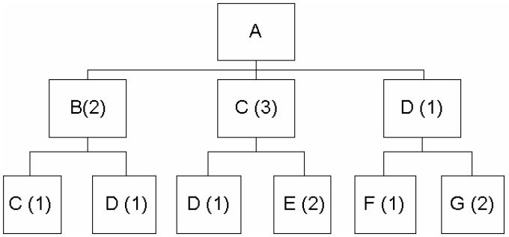

If the demand for product A is 50 units, what will be the gross requirement for component E?
A) 4
B) 100
C) 200
D) 250
E) 300
Answer: E
Diff: 2
Topic: Dependent inventory model requirements
AACSB: Analytic Skills
Objective: LO14-1

63) Given the following bill of material

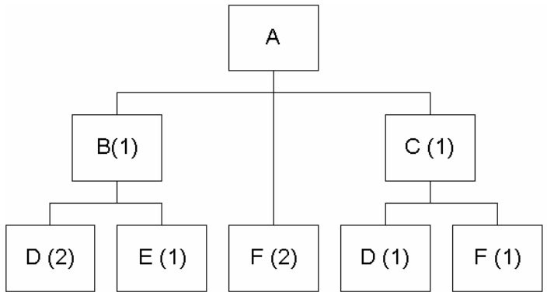

If the demand for product A is 50 units, what will be the gross requirement for component E?
A) 50
B) 100
C) 150
D) 200
E) 300
Answer: A
Diff: 2
Topic: Dependent inventory model requirements
AACSB: Analytic Skills
Objective: LO14-1
64) When safety stock is deemed absolutely necessary, the usual policy is to build it into which category of the MRP logic?
A) Gross Requirements
B) Scheduled Receipts
C) Projected On Hand
D) Net Requirements
E) Planned Order Receipts
Answer: C
Diff: 2
Topic: MRP structure
Objective: LO14-2

65) Given the following bill of material

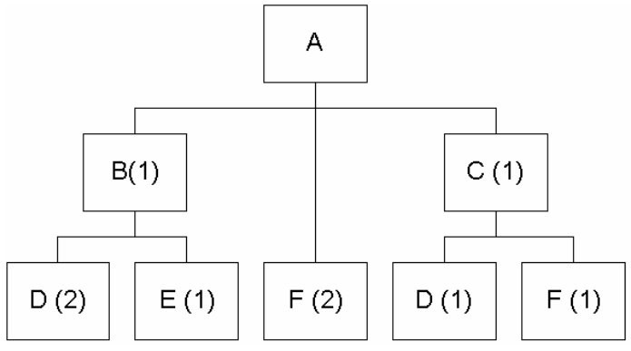

If the demand for product A is 30 units, and there are 10 units of B on hand and none of C, how many units of part D will be needed?
A) 3
B) 40
C) 70
D) 90
E) 110
Answer: C
Diff: 3
Topic: Dependent inventory model requirements
AACSB: Analytic Skills
Objective: LO14-1
66) Low level coding means that
A) a final item has only a few levels in the BOM structure
B) it is the code for the lowest level in the BOM structure
C) a component item is coded at the lowest level at which it appears in the BOM structure
D) the top level of the BOM is below level zero and that BOMs are not organized around the finished product
E) none of the above
Answer: C
Diff: 2
Topic: Dependent inventory model requirements
Objective: LO14-1

67) It is week 1 and there are currently 20 As in stock. The MPS calls for 300 As at the start of week 5. If there are scheduled receipts planned for week 3 and week 4 of 120 As each and A has a lead time of 1 week when and how large of an order should be placed to meet the requirement of 300 As?
A) Week 1, 300 A s
B) Week 1, 40 A s
C) Week 5, 40 A s
D) Week 4, 40 A s
E) Week 4, 300 A s
Answer: D
Diff: 2
Topic: MRP structure
AACSB: Analytic Skills
Objective: LO14-3

68) If safety stock is desired it should be built into which portion of MRP?
A) any
B) none
C) raw materials
D) finished assemblies
E) either C or D
Answer: E
Diff: 2
Topic: MRP structure
Objective: LO14-3
69) Each X requires 2 of component Y; each Y requires 4 of part Z. The lead time for assembly of X is 1 week. The lead time for the manufacture of Y is 1 week. The lead time for the procurement of Z is 6 weeks. The cumulative lead time for X is __________ weeks.
A) 6
B) 7
C) 8
D) 10
E) cannot be determined
Answer: C
Diff: 2
Topic: MRP structure
AACSB: Analytic Skills
Objective: LO14-2

70) A material requirements plan contains information with regard to all of the following except
A) quantities and required delivery dates of all subassemblies
B) quantities and required delivery dates of final products
C) the capacity needed to provide the projected output rate
D) inventory on hand for each final product
E) inventory on hand for each subassembly
Answer: C
Diff: 2
Topic: MRP structure
Objective: LO14-3
71) Each R requires 2 of component S and 1 of part T. The lead time for assembly of R is 3 days. The lead time for the manufacture of S is 5 days. The lead time for the manufacture of T is 10 days. The cumulative lead time for R is __________ days.
A) 6
B) 9
C) 13
D) 17
E) cannot be determined
Answer: C
Diff: 2
Topic: MRP structure
AACSB: Analytic Skills
Objective: LO14-2
72) Each R requires 4 of component S; each S requires 3 of part T. The lead time for assembly of R is 1 week. The lead time for the manufacture of S is 2 weeks. The lead time for the procurement of T is 6 weeks. The cumulative lead time for R is __________ weeks.
A) 6
B) 9
C) 12
D) 18
E) 28
Answer: B
Diff: 2
Topic: MRP structure
AACSB: Analytic Skills
Objective: LO14-2

73) Which of the following best describes a gross material requirements plan?
A) a schedule that shows total demand for an item, and when it must be ordered from a supplier or when production must be started
B) an intermediate range plan for the scheduling of families of products
C) a chart illustrating whether capacity has been exceeded
D) a table that corrects scheduled quantities for inventory on hand
E) a schedule showing which products are to be manufactured and in what quantities
Answer: A
Diff: 2
Topic: MRP structure
Objective: LO14-2

74) Which of the following statements regarding the gross material requirements plan is true?
A) It shows total demand for an item.
B) It shows when an item must be ordered from a supplier or when production must be started.
C) It combines a master production schedule with the time-phased schedule.
D) It requires several inputs, including an accurate bill of material.
E) All of the above are true.
Answer: E
Diff: 2
Topic: MRP structure
Objective: LO14-2

75) The MPS calls for 110 units of Product M. There are currently 30 of Product M on hand. Each M requires 4 of Component N. There are 20 units of N on hand. The net requirements for N are
A) 150
B) 170
C) 300
D) 320
E) 440
Answer: C
Diff: 2
Topic: MRP structure
AACSB: Analytic Skills
Objective: LO14-3
76) The MPS calls for 50 units of Product A and 60 of B. There are currently 25 of Product B on hand. Each A requires 2 of Part C; each B requires 5 of C. There are 160 units of C available. The net requirements for C are
A) 115
B) 175
C) 240
D) 690
E) 700
Answer: A
Diff: 3
Topic: MRP structure
AACSB: Analytic Skills
Objective: LO14-3

77) The MPS calls for 110 units of Product A. There are currently 60 of Product A on hand. Each A requires 4 of Part B. There are 20 units of B available. The net requirements for B are
A) 20
B) 120
C) 180
D) 240
E) 440
Answer: C
Diff: 2
Topic: MRP structure
AACSB: Analytic Skills
Objective: LO14-3

78) In MRP record calculations, the appearance of a negative value for the gross requirements of an end item in a specific time bucket
A) signals the need to purchase that end item in that period
B) implies that value was scheduled by the MPS
C) signals the need for a negative planned order receipt in that period
D) is impossible
E) All of the above are true.
Answer: D
Diff: 2
Topic: MRP structure
Objective: LO14-3

79) The number of units projected to be available at the end of each time period refers to
A) net requirements
B) scheduled receipts
C) the projected usage of the item
D) the amount projected to be on hand
E) the amount necessary to cover a shortage
Answer: D
Diff: 2
Topic: MRP structure
Objective: LO14-3
80) Linking a part requirement with the parent component that caused the requirement is referred to as
A) net requirements planning
B) a time fence
C) pegging
D) kanban
E) leveling
Answer: C
Diff: 2
Topic: MRP management
Objective: LO14-3

81) In MRP, system nervousness is caused by
A) management's attempt to continually respond to minor changes in production requirements
B) the use of the lot-for-lot approach
C) management's marking part of the master production schedule as "not to be rescheduled"
D) the use of phantom bills of material
E) management's attempt to evaluate alternative plans before making a decision
Answer: A
Diff: 2
Topic: MRP management
Objective: LO14-3

82) One of the tools that is particularly useful in reducing the system nervousness in the MRP system is (are)
A) modular bills
B) time phasing
C) time fences
D) lot sizing
E) closed loop system
Answer: C
Diff: 2
Topic: MRP management
Objective: LO14-3

83) Which of the following is a step towards integrating JIT and MRP according to the text?
A) smaller buckets
B) increase quality
C) scrap MRP, it does not work with JIT
D) migrate from MRP to ERP
E) All of the above are acceptable steps
Answer: A
Diff: 2
Topic: MRP management
Objective: no LO
84) Distortion in MRP systems can be minimized when safety stock is held at the
A) purchased component or raw material level
B) work-in-process level
C) finished goods level
D) A and B
E) A and C
Answer: E
Diff: 3
Topic: MRP structure
Objective: no LO

85) Material requirements plans specify
A) the quantities of the product families that need to be produced
B) the quantity and timing of planned order releases
C) the capacity needed to provide the projected output rate
D) the costs associated with alternative plans
E) whether one should use phantom bills of material or not
Answer: B
Diff: 2
Topic: MRP structure
Objective: LO14-2

86) Which of the following best differentiates material requirements planning (MRP) from finite capacity scheduling (FCS)?
A) FCS recognizes the finite nature of capacity while MRP does not.
B) FCS works in services while MRP does not.
C) MRP requires time buckets while FCS does not.
D) FCS is an input into traditional MRP systems.
E) FCS uses the Wagner-Whitin algorithm while MRP uses lot-for-lot and EOQ.
Answer: A
Diff: 2
Topic: MRP management
Objective: no LO

87) Which of the following lot-sizing techniques results in the lowest holding costs?
A) lot-for-lot
B) EOQ
C) part-period balancing
D) Wagner-Whitin algorithm
E) the quantity discount model
Answer: A
Diff: 2
Topic: Lot-sizing techniques
Objective: LO14-4
88) Which of the following statements is true about the MRP plan when using lot-for-lot ordering?
A) The quantity of gross requirements for a child item is always equal to the quantity of planned order releases for its parent.
B) The quantity of gross requirements for a child item is equal to the quantity of planned order release(s) multiplied by the number of child items used in the parent assembly.
C) The quantity of gross requirements for a child item is always equal to the quantity of gross requirements for its parent.
D) The quantity and gross requirements for a child item is always equal to the quantity of net requirements for its parent.
E) All of the above are true.
Answer: B
Diff: 2
Topic: MRP structure
Objective: LO14-3

89) What lot-sizing technique is generally preferred when inventory holding costs are extremely high?
A) lot-for-lot
B) EOQ
C) part-period balancing
D) the Wagner-Whitin algorithm
E) All of the above are appropriate for the situation.
Answer: A
Diff: 2
Topic: Lot-sizing techniques
Objective: LO14-4

90) For the lot-sizing technique known as lot-for-lot to be appropriate
A) future demand should be known for several weeks
B) setup cost should be relatively small
C) annual volume should be rather low
D) item unit cost should be relatively small
E) the independent demand rate should be very stable
Answer: B
Diff: 2
Topic: Lot-sizing techniques
Objective: LO14-4

91) An item's holding cost is 60 cents per week. Each setup costs $120. Lead time is 2 weeks. EPP is
A) .005
B) 60
C) 72
D) 100
E) 200
Answer: E
Diff: 2
Topic: Lot-sizing techniques
AACSB: Analytic Skills
Objective: LO14-4
92) Which of the following statements regarding lot-sizing is true?
A) EOQ principles should be followed whenever economical.
B) Too much concern with lot-sizing results in false accuracy.
C) Lot-for-lot cannot be modified for scrap allowance or process constraints.
D) The Wagner-Whitin algorithm simplifies lot size calculations.
E) All of the above are true.
Answer: B
Diff: 2
Topic: Lot-sizing techniques
Objective: LO14-4

93) A firm makes numerous models of mowers, garden tractors, and gasoline powered utility vehicles. Some assemblies and parts are common to many end items. To relieve the MPS of performing order releases on these common parts, the firm might choose to use the __________ technique.
A) Wagner-Whitin
B) economic part period
C) supermarket
D) gross material requirements
E) resource requirements profile
Answer: C
Diff: 2
Topic: MRP management
Objective: LO14-1

94) Capacity planning in closed-loop MRP
A) utilizes feedback about workload from each work center
B) may make use of resource requirements profiles (load reports)
C) may smooth work center loads with such tactics as overlapping and lot splitting
D) does not add capacity, but rather seeks effective use of existing capacity
E) All of the above are true.
Answer: E
Diff: 2
Topic: Extensions of MRP
Objective: LO14-6

95) If a load report (resource requirements profile) shows a work center scheduled beyond capacity
A) the company must add capacity by enlarging the facility
B) the company must add capacity by such tactics as overtime and subcontracting
C) the work center's load may be smoothed by such tactics as operations splitting or lot splitting
D) the aggregate plan must be revised
E) the Wagner-Whitin algorithm should be used to rebalance the load
Answer: C
Diff: 2
Topic: Extensions of MRP
Objective: LO14-6
96) MRP II is accurately described as
A) MRP software designed for services
B) MRP with a new set of computer programs that execute on microcomputers
C) MRP augmented by other resource variables
D) an enhancement of MRP that plans for all levels of the supply chain
E) a new generation of MRP software that extends MRP to planning and scheduling functions
Answer: C
Diff: 2
Topic: Extensions of MRP
Objective: LO14-5

97) The extension of MRP which extends to resources such as labor hours and machine hours, as well as to order entry, purchasing, and direct interface with customers and suppliers is
A) MRP II
B) enterprise resource planning
C) the master production schedule
D) closed-loop MRP
E) not yet technically possible
Answer: B
Diff: 2
Topic: Extensions of MRP
Objective: LO14-7

98) Which of the following statements regarding MRP in services is true?
A) MRP is for manufacturing only, and is not applicable to services.
B) MRP can be used in services, but only those that offer very limited customization.
C) MRP does not work in services because there is no dependent demand.
D) Services such as restaurant meals illustrate dependent demand, and require product structure trees, bills-of-material, and scheduling.
E) None of the above is true.
Answer: D
Diff: 2
Topic: MRP in services
Objective: no LO

99) Distribution resource planning (DRP) is
A) a transportation plan to ship materials to warehouses
B) a time-phased stock replenishment plan for all levels of a distribution network
C) a shipping plan from a central warehouse to retail warehouses
D) material requirements planning with feedback loop from distribution centers
E) a material requirements planning package used exclusively by warehouses
Answer: B
Diff: 2
Topic: MRP in services
Objective: no LO
100) By convention, the top level in a bill of material is
A) level 0
B) level 1
C) level T
D) level 10
E) level 100
Answer: A
Diff: 2
Topic: Dependent inventory model requirements
Objective: LO14-1

101) Enterprise resource planning (ERP)
A) seldom requires software upgrade or enhancement
B) does not integrate well with functional areas other than operations
C) is inexpensive to implement
D) automates and integrates the majority of business processes
E) all of the above
Answer: D
Diff: 2
Topic: Enterprise resource planning (ERP)
Objective: LO14-7

102) Enterprise resource planning (ERP)
A) has been made possible because of advances in hardware and software
B) uses client/server networks
C) creates commonality of databases
D) uses business application-programming interfaces (BAPI) to access their database
E) All of the above are true of ERP.
Answer: E
Diff: 2
Topic: Enterprise resource planning (ERP)
AACSB: Use of IT
Objective: LO14-7

103) Which of the following is false concerning enterprise resource planning (ERP)?
A) It attempts to automate and integrate the majority of business processes.
B) It shares common data and practices across the enterprise.
C) It is inexpensive to implement.
D) All of the above are true.
Answer: C
Diff: 2
Topic: Enterprise resource planning (ERP)
Objective: LO14-7
104) Which of the following regarding enterprise resource planning (ERP) is true?
A) It involves an ongoing process for implementation.
B) It can incorporate improved, reengineered "best processes."
C) It has a software database that is off-the-shelf coding.
D) ERP systems usually include MRP, financial and human resource information.
E) All of the above are true.
Answer: E
Diff: 2
Topic: Enterprise resource planning (ERP)
Objective: LO14-7

105) All of the following are advantages of enterprise resource planning (ERP) except it
A) creates commonality of databases
B) increases communications and collaboration worldwide
C) helps integrate multiple sites and business units
D) requires major changes in the company and its processes to implement
E) can provide a strategic advantage over competitors
Answer: D
Diff: 2
Topic: Enterprise resource planning (ERP)
AACSB: Communication
Objective: LO14-7

106) Wheeled Coach uses __________ as the catalyst for low inventory, high quality, tight schedules, and accurate records.
Answer: material requirements planning or MRP
Diff: 1
Topic: Global company profile
Objective: no LO

107) __________ is a dependent demand technique that uses a bill of material, inventory, expected receipts, and a master production schedule to determine material requirements.
Answer: Material requirements planning or MRP
Diff: 1
Topic: Dependent demand
Objective: no LO

108) A(n) __________ is a timetable that specifies what is to be made and when.
Answer: master production schedule or MPS
Diff: 1
Topic: Dependent inventory model requirements
Objective: no LO

109) A(n) __________ is a listing of the components, their description, and the quantity of each required to make one unit of a product.
Answer: bill of material or BOM
Diff: 2
Topic: Dependent inventory model requirements
Objective: LO14-1
110) A process-focus facility (for example, a print shop) will likely schedule __________ as the focus of its master production schedule.
Answer: customer orders
Diff: 1
Topic: Dependent inventory model requirements
Objective: LO14-2

111) Bills of material organized by major subassemblies or by product options are called __________.
Answer: modular bills
Diff: 2
Topic: Dependent inventory model requirements
Objective: LO14-1

112) The __________ is used to correct an erroneous dimension, quantity, or other specification in a bill of material.
Answer: engineering change notice
Diff: 1
Topic: Dependent inventory model requirements
Objective: LO14-1

113) A(n) __________ is a bill of material for components, usually assemblies that exist only temporarily; they are never inventoried.
Answer: Phantom bill of material
Diff: 2
Topic: Dependent inventory model requirements
Objective: LO14-1

114) __________ are the result of adjusting gross requirements for inventory on hand and scheduled receipts.
Answer: Net material requirements
Diff: 2
Topic: MRP structure
Objective: LO14-3

115) __________ are a way of allowing a segment of the master schedule to be designated as "not to be rescheduled."
Answer: Time fences
Diff: 2
Topic: MRP management
Objective: no LO

116) __________, unlike MRP, recognizes that departments and machines have limitations on their capacity that must be observed if the schedule is to be realistic.
Answer: Finite capacity scheduling or FCS
Diff: 1
Topic: MRP management
Objective: no LO
117) __________ refers to the time units in a material requirements planning (MRP) system.
Answer: Buckets
Diff: 1
Topic: MRP management
Objective: no LO

118) __________ is a lot-sizing technique that generates exactly what is required to meet the plan.
Answer: Lot-for-lot
Diff: 2
Topic: Lot-sizing techniques
Objective: LO14-4

119) The __________ technique may be applicable where a firm's parts and subassemblies are common to a variety of its products.
Answer: supermarket
Diff: 1
Topic: MRP management
Objective: LO14-1

120) A(n) __________ provides feedback to the capacity plan, master production schedule, and production plan so planning can be kept valid at all times.
Answer: closed-loop MRP system
Diff: 2
Topic: Extensions of MRP
Objective: LO14-6

121) A(n) __________ can illustrate whether a work center has been scheduled beyond its capacity.
Answer: load report or resource requirement profile
Diff: 1
Topic: Extensions of MRP
Objective: LO14-6

122) __________ is a system that allows, with MRP in place, inventory data to be augmented by other resource variables.
Answer: Material requirements planning II or material resource planning or MRP II
Diff: 2
Topic: Extensions of MRP
Objective: LO14-5

123) A(n) __________ system is packaged business software that automates and integrates the majority of their business processes, shares common data and practices across the entire enterprise, and produces and accesses information in a real-time environment.
Answer: enterprise resource planning or ERP
Diff: 2
Topic: Enterprise resource planning (ERP)
AACSB: Use of IT
Objective: LO14-7
124) Describe the role of record accuracy in Wheeled Coach's successful use of MRP. Is this company's experience the exception or the rule? Answer in a well-developed paragraph.
Answer: Wheeled Coach's record integrity is excellent. They have accurate bills of material and of inventory; they use cycle counters for material audits and error detection. Record accuracy is recognized as a fundamental ingredient of successful MRP implementation. Thus Wheeled Coach's excellent record integrity is expected; they would not have successful use of MRP without it.
Diff: 1
Topic: Global company profile
Objective: no LO

125) What is MRP? Identify four benefits from its use.
Answer: MRP or material requirements planning is a dependent demand technique that uses a bill of material, inventory expected receipts, and a master production schedule to determine material requirements. The benefits of MRP include better response to customer orders, faster response to market changes, improved utilization of facilities and labor, and reduced inventory levels.
Diff: 1
Topic: Dependent demand
Objective: no LO

126) How does the process choice of an organization affect the basis of its master production schedule?
Answer: In a continuous focus (make-to-stock) company, the MPS will likely be expressed in end items; in a process focus (make-to-order) company, customer orders will likely be the basis of the MPS; and in a repetitive process (assemble-to-stock) company, the basis will be its modules.
Diff: 2
Topic: Dependent inventory model requirements
Objective: LO14-2

127) If the explosion of the bill of material tells MRP how much of each part is needed, how does MRP learn when each of these parts is needed?
Answer: Timing is established with the time-phased product structure, which factors item quantities with item lead times. The lead times are cumulative, in the sense that the lead time for a child part is the sum of its lead time and that of all of its parent components.
Diff: 2
Topic: Dependent inventory model requirements
Objective: LO14-2

128) Explain the difference between a gross requirements plan and a net requirements plan.
Answer: A gross requirements plan multiplies each part quantity in the bill of material by the number of top level parents needed. This ignores any inventory on hand, whether of parents or children. A net requirements plan starts with the top level requirements from the bill of material, then subtracts inventory of that item on hand. This net requirement becomes the gross requirement to the next level of the product structure.
Diff: 1
Topic: MRP structure
Objective: LO14-3
129) Describe briefly the information requirements of basic and extended MRP systems. Comment on the challenge of maintaining timely, accurate information for a large manufacturing operation based on MRP.
Answer: MRP requires very high accuracy of inventory data file. MRP needs inputs from the master production schedule, bills of material, inventory records, and expected receipts. As MRP is extended to MRP II and ERP, the information needs are intensified.
Diff: 2
Topic: MRP structure and Extensions of MRP
Objective: LO14-5

130) What information is necessary for an operations manager to make effective use of a dependent inventory demand model?
Answer: The information necessary for an operations manager to make effective use of a dependent inventory demand model are the master production schedule (what is to be made, and when); specifications or bills of material (how to make the product); inventory availability (what is in stock); purchase orders outstanding (what is on order); and lead times (how long does it take to get or make each component).
Diff: 2
Topic: MRP structure
Objective: no LO

131) A working MRP system allows a firm to react to even minor changes in production requirements. Discuss both the advantages and disadvantages of having such ability.
Answer: The advantages are it allows the firm to react quickly and, conceivably, to minimize costs. The disadvantages are the reaction to a large number of minor changes may introduce instability (nervousness) into the purchasing and production departments.
Diff: 2
Topic: MRP structure
Objective: no LO

132) An error has been detected in the technical drawing of a product about to be placed on a master production schedule. The part should be 9" by 12", not 9 cm by 12 cm; further, the part should be stainless steel, not ordinary steel. What document transmits the needed change? Where is the corrected information recorded? Why is this important to the master production schedule?
Answer: An engineering change notice or ECN is the document that corrects the error; the correction is made on the bill of material for that product. Accurate records are a necessity for successful use of MRP. In this case, the wrong part would be made or purchased, then sent to assembly. The product could not be correctly made, the schedule could not be met, and the customer's order could not be delivered.
Diff: 2
Topic: Dependent inventory model requirements
Objective: LO14-1

133) What are time fences? Why are they used?
Answer: Time fences allow a segment of the master schedule to be designated as "not to be rescheduled." They are used to reduce system nervousness in MRP environments.
Diff: 2
Topic: MRP management
Objective: no LO
134) Explain what is meant by "nervousness" of the MRP schedule. Provide an example. Name two tools that are particularly useful in reducing system nervousness in MRP systems.
Answer: Nervousness is the reaction to a large number of minor changes that may introduce instability into the purchasing and production departments. Two tools for reducing system nervousness are time fences and pegging.
Diff: 2
Topic: MRP management
Objective: no LO

135) Describe finite capacity scheduling. How is it more realistic than MRP?
Answer: FCS provides the precise scheduling needed for rapid material movement. MRP schedules work without regard to capacity. Finite capacity scheduling factors department and machine capacity into its scheduling, and is thus more realistic than MRP.
Diff: 1
Topic: MRP and JIT
Objective: no LO

136) What is the "supermarket" as it is used in MRP? How does it alter the responsibility for dealing with lead-time offsets?
Answer: The supermarket concept applies when parts and assemblies are common to various end items. These items are inventoried in the supermarket so that the master production scheduler does not issue order releases for them. These parts can simply be picked up, and have no lead time. Maintaining the supermarket is done through kanban methods, not MRP.
Diff: 2
Topic: MRP management
Objective: no LO

137) You have seen several methods for lot sizing in MRP. Why is lot sizing important in MRP? Can too much concern be given lot sizing? Answer in a well-developed paragraph.
Answer: Lot sizing is important because, at the very least, it impacts costs. But too much attention can be paid to lot sizing, which can result in false accuracy. Also, several lot-sizing methods may all produce satisfactory results. Finally, proper lot size is often not possible to determine until after actual requirements are known.
Diff: 2
Topic: Lot-sizing techniques
Objective: LO14-4

138) What does the part-period balancing lot-sizing technique attempt to do in deciding the lot sizes?
Answer: It balances the setup and holding costs. PPB uses additional information by changing the lot size to reflect requirements of the next lot size in the future.
Diff: 2
Topic: Lot-sizing techniques
Objective: LO14-4
139) Describe how MRP II differs from MRP.
Answer: MRP II is MRP in which inventory data are augmented by labor hours, material cost, capital cost, or by virtually any resource.
Diff: 2
Topic: Extensions of MRP
Objective: LO14-5
140) How can MRP and JIT be effectively integrated?
Answer: One approach is the small bucket approach that involves the following steps:
1. Reduce the MRP buckets from weekly to daily to perhaps hourly.
2. The planned receipts that are part of a firm's planned orders in an MRP system are communicated to the work areas and are used to sequence production.
3. Inventory is moved through the plant on a JIT basis.
4. As products are completed, they are moved into inventory in the normal way.
5. A back flush is used to reduce inventory balances.
Another approach is the balanced flow. In this system, execution is achieved by maintaining a carefully balanced flow of materials to assembly areas with small lot sizes.

Diff: 3
Topic: MRP management
Objective: no LO

141) Identify the several lot-sizing algorithms used in MRP. Provide at least one advantage and one disadvantage of each.
Answer:
Algorithm | Advantage | Disadvantage
Lot-for-lot | no inventory; use whenever economical | expensive when setup costs are significant
Wagner-Whitin | good results | complexity
Part period balancing | Lot size varies with needs; good when setup cost is significant | not always optimal
Economic order quantity (EOQ) | use when the demand is constant and setup costs are high | lot size fixed; incurs holding costs; works best with independent demand

Diff: 2
Topic: Lot-sizing techniques
Objective: LO14-4

142) Describe the tactics for load smoothing in MRP.
Answer: Overlapping - send pieces to the second operation before the entire lot is completed on the first operation; operations splitting - send the lot to two different machines for the same operation; and lot splitting - break up the order and run part of it ahead of schedule.
Diff: 2
Topic: Extensions of MRP
Objective: LO14-5
143) What do we mean by closed-loop MRP?
Answer: Closed-loop MRP indicates that (a) there is both a planning and execution phase, and (b) information from the execution phase is fed back to the planning phase. Once planning is complete, an attempt is made to execute the "planned" schedule. Information is fed back from the execution of this schedule to the planning phase so the plans can be modified as necessary.
Diff: 2
Topic: Extensions of MRP
Objective: LO14-6

144) What types of resources might be scheduled via an MRP II system?
Answer: Virtually all resources can be evaluated via MRP II. This includes material, labor, cash, and facilities.
Diff: 2
Topic: Extensions of MRP
Objective: LO14-5

145) What is DRP?
Answer: DRP is a time-phased stock replenishment plan for all levels of a distribution network.
Diff: 2
Topic: MRP in services
Objective: no LO

146) Compare MRP in services to MRP in manufacturing. Utilize a simple example in your comparison.
Answer: Services can exhibit dependent demand, just like parts and assemblies in manufacturing. Such services can require product structure trees, bills of material, bills of labor, and scheduling. These are the same features that make MRP attractive to manufacturers. Examples will vary, but here is a sample drawn from food service. One can construct a product structure tree and bill of material for a restaurant meal; lead time offsets are vital; otherwise the elements of the meal would not be served in the right order or at the proper temperature.
Diff: 2
Topic: MRP in services
Objective: no LO

147) What does enterprise resource planning (ERP) allow an organization to do?
Answer: It allows them to automate and integrate the majority of their business processes, to share common data and practices across the entire enterprise, and to produce and access information in a real-time environment.
Diff: 2
Topic: Enterprise resource planning (ERP)
AACSB: Use of IT
Objective: LO14-7
148) What are the advantages of enterprise resource planning (ERP)?
Answer: ERP provides integration of the supply chain, production, and administrative processes; creates commonality of databases; incorporates improved, redesigned, or "best" practices; increases communication and collaboration worldwide; helps integrate multiple sites and business units; comes with software core that is off-the-shelf coding; and provides a strategic advantage over competitors.
Diff: 2
Topic: Enterprise resource planning (ERP)
AACSB: Use of IT
Objective: LO14-7

149) What are the disadvantages of enterprise resource planning (ERP)?
Answer: ERP is very expensive to purchase, and even more costly to customize; requires major changes in the company and processes to implement; is such a complex program that many companies cannot adjust to it; involves an ongoing process for implementation, often never completed; and expertise in ERP is limited, with staffing an ongoing problem.
Diff: 2
Topic: Enterprise resource planning (ERP)
AACSB: Use of IT
Objective: LO14-7

150) Consider the following bill of material. Fifty units of Product A are needed. Assuming no on-hand inventory, and no scheduled receipts, explode the bill of material.
Answer:
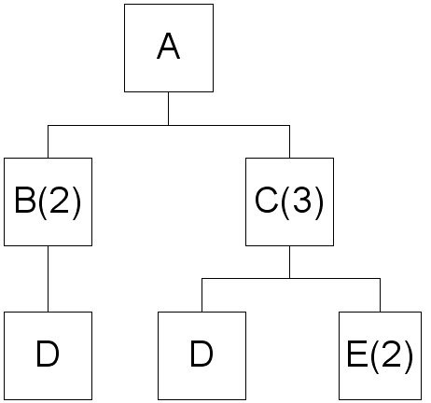

Item A: 50 units; Item B: 50 * 2 = 100 units; Item C: (50 * 3) = 150 units; Item D: (50 * 2 * 1) + (50 * 3 * 1) = 250 units; Item E: (50 *3 * 2) = 300 units.
Diff: 2
Topic: MRP structure
AACSB: Analytic Skills
Objective: LO14-1
151) The large parts of a playground A-frame (from which to hang a swing or glider) consist of a ridge pole, four legs, and two side braces. Each pair of legs fastens to the ridge with one fastener set. Each side brace requires two fastener sets for attachment to the legs. Each fastener set includes one zinc-plated bolt, one lock-washer, and one nut.

There is one order outstanding, to make 80 frame kits. There are 200 legs in inventory. There are no other large items in inventory, and no scheduled receipts. Fasteners are available from the small parts area.
a. Draw the product structure tree
b. Calculate the net requirements to fulfill the outstanding order.
Answer: Solution:
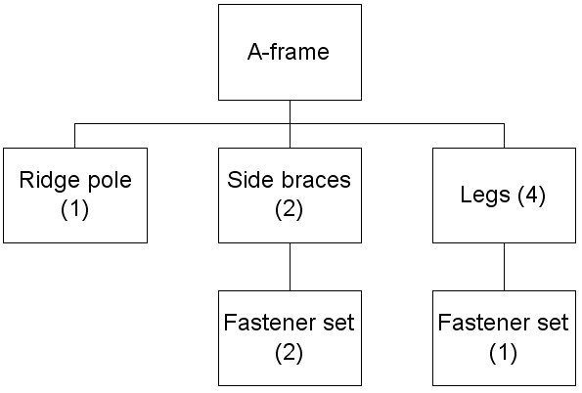

Part | GR | OH | NR
A-frame | 80 |  | 80
Ridge pole | 80 |  | 80
Side braces | 160 |  | 160
Legs | 320 | 200 | 120
Fastener set | 440 |  | 440

Diff: 1
Topic: MRP structure
AACSB: Analytic Skills
Objective: LO14-1

152) A very simple product (A) consists of a base (B) and a casting (C). The base consists of a plate (P) and three fasteners (F). There are currently 30 castings and 100 bases on hand. Final assembly takes one week. The casting has a lead time of three weeks. All other parts have one week lead times. There are no scheduled receipts. All components are lot-for-lot. The MPS requires 80 units of product A in week 5 and 120 in week 8. Produce the MRP for the upcoming eight weeks. Produce a list of all planned order releases.
Answer:
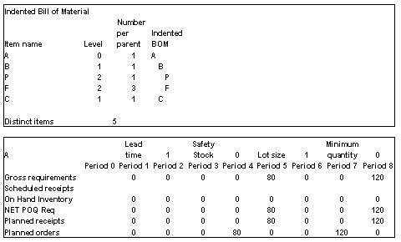
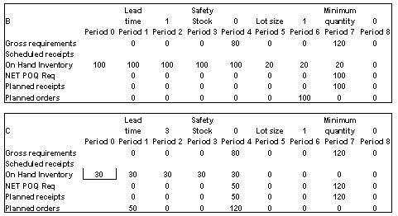
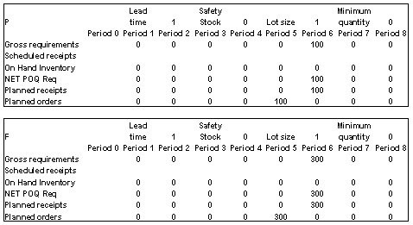
Diff: 2
Topic: MRP structure
AACSB: Analytic Skills
Objective: LO14-3

153) Consider the following requirements for a certain product.

Period | 1 | 2 | 3 | 4 | 5 | 6 | 7 | 8
Gross requirements | 0 | 200 | 200 | 500 | 0 | 400 | 0 | 400

Beginning inventory = 500 units
Setup cost = $500 per setup
Lead time = 1 week
Holding cost = $3 per unit per week
a. Develop the lot-for-lot MRP table.
b. Calculate the total relevant costs.
Answer: There are three setups at $500 each, totaling $1,500. There are 500 units held in period 1 and 2, and 300 in period 3. The holding costs are 1300 units x $3 per unit, for a total of $3,900. Total relevant costs are $5,400.

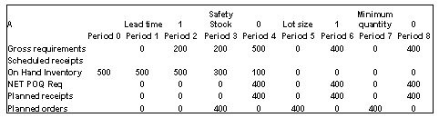
Diff: 1
Topic: Lot-sizing techniques
AACSB: Analytic Skills
Objective: LO14-4
154) Consider the following bill of material. Fifty units of Product A are needed. Assuming no on-hand inventory, explode the bill of material.

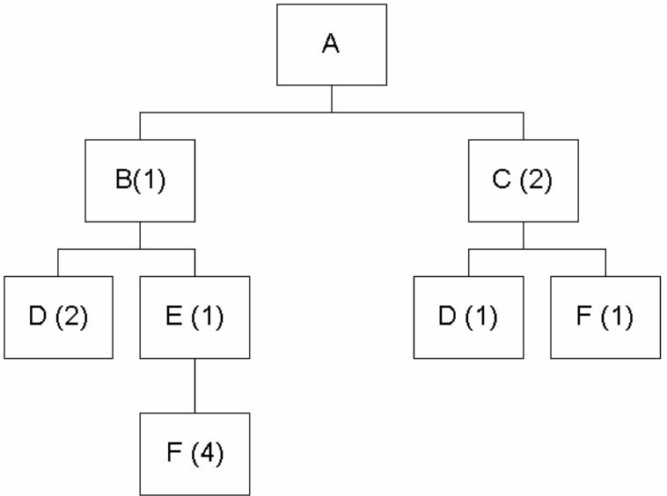
Answer: Item A: 50 units; Item B: 50 * 1 = 50 units; Item C: (50 * 2) = 100 units; Item D: (50 * 2 * 1) + (100 * 1) = 200 units; Item E: (50 * 1 * 1) = 50 units; Item F: (50 * 1 * 1 * 4) + (50 * 2 * 1) = 300 units. (
Diff: 2
Topic: MRP structure
AACSB: Analytic Skills
Objective: LO14-1
155) Consider the following bill of material. Forty units of Product A are needed. Assuming no on-hand inventory, and no scheduled receipts, explode the bill of material.

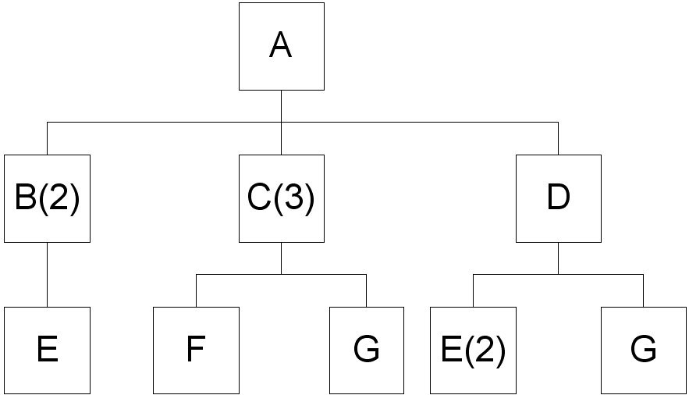
Answer: Item A: 40 units; Item B: 40 * 2 = 80 units; Item C: (40 * 3) = 120 units; Item D: (40 * 1) = 40 units; Item E: (80 * 1) + (40 * 2) = 160 units; Item F: (120 * 1) = 120 units; Item G: 120 + 40 160 units.
Diff: 2
Topic: MRP structure
AACSB: Analytic Skills
Objective: LO14-1
156) Clancy's Motors has the following demand to meet for custom manufactured fuel injector parts. The holding cost for that item is $.75 per month and each setup costs $150. Calculate the order quantity by use of the part-period algorithm. Lead time is 2 months.

Month | 1 | 2 | 3 | 4 | 5 | 6 | 7
Requirement | 100 | 150 | 200 | 150 | 100 | 150 | 250

Answer:
EPP = 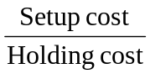 = 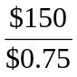 = 200 units

In Period 1, an order for 250 units should be received; in Period 3, an order for 350 units should be received; in Period 5, an order for 250 units should be received, and in Period 7, an order for 250 should be received, as per the table below.

Period | Order size | # of Units | # period | PP | CumPP
1 | 100 | 0
1, 2 | 250 | 150 | 1 | 150 | 150*
1, 2, 3 | 450 | 200 | 2 | 400 | 550
3 | 200 | 0
3, 4 | 350 | 150 | 1 | 150 | 150*
3, 4, 5 | 450 | 100 | 2 | 200 | 350
5 | 100 | 0
5,6 | 250 | 150 | 1 | 150 | 150*
5,6,7 | 500 | 250 | 2 | 500 | 650
7 | 250

Diff: 2
Topic: Lot-sizing techniques
AACSB: Analytic Skills
Objective: LO14-4

157) The MPS calls for 120 units of Product M. There are currently 30 of Product M on hand. Each M requires 4 of Component N. There are 20 units of N on hand.
a. Calculate the net requirements for M.
b. Calculate the gross requirements for N.
c. Calculate the net requirements for N.
Answer: (a) 120 - 30 = 90; (b) 90 x 4 = 360; 360 - 20 = 340
Diff: 1
Topic: MRP structure
AACSB: Analytic Skills
Objective: LO14-3
158) The MPS calls for 110 units of Product A. There are currently 60 of Product A on hand. Each A requires 2 of Part B. There are 30 units of B available.
a. Calculate the net requirements for A.
b. Calculate the gross requirements for B.
c. Calculate the net requirements for B.
Answer: (a) 110 - 60 = 50; (b) 50 x 2 = 100; (c) 100 - 30 = 70
Diff: 1
Topic: MRP structure
AACSB: Analytic Skills
Objective: LO14-3

159) The MPS calls for 50 units of Product A and 60 of B. There are currently 35 of Product B on hand. Each A requires 2 of Part C; each B requires 5 of C. There are 160 units of C available.
a. Calculate the net requirements for B.
b. Calculate the gross requirements for C.
c. Calculate the net requirements for C.
Answer: (a) 60 - 35 = 25; (b) 50 x 2 + 25 x 5 = 225; (c) 225 - 160 = 65
Diff: 1
Topic: MRP structure
AACSB: Analytic Skills
Objective: LO14-3

160) Consider the bill of material for Product J and the data given in the following table. The gross requirements for J are 200 units in week 6 and 250 units in week 8. Develop the MRP tables for each item for an 8-week planning period. Use the lot-for-lot lot-sizing rule.

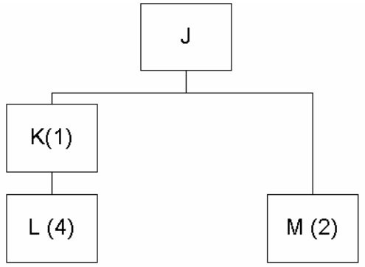

Item | Lead Time | Quantity on Hand | Scheduled receipts
J | 1 | 0
K | 2 | 20 | 30 in week 2
L | 2 | 0
M | 1 | 20 | 10 in week 1

Answer:
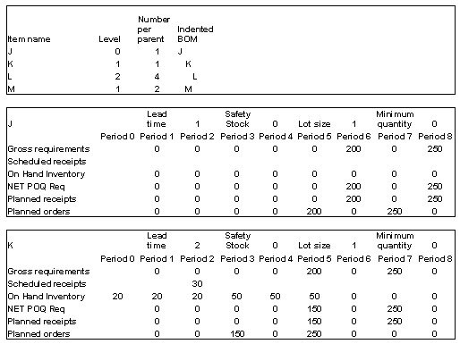
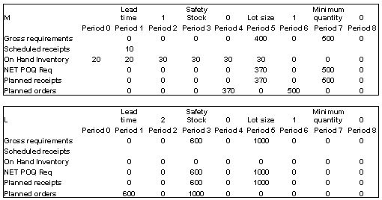
Diff: 2
Topic: MRP structure
AACSB: Analytic Skills
Objective: LO14-3
161) Each R requires 3 of component S and 3 of material A; each S requires 3 of part T. The lead time for assembly of R is 1 week. The lead time for the manufacture of S is 2 weeks. The lead time for material A is 1 week. The lead time for the procurement of T is 4 weeks.
a. Construct the time-phased product structure.
b. Construct the bill of material.
Answer: Solution:

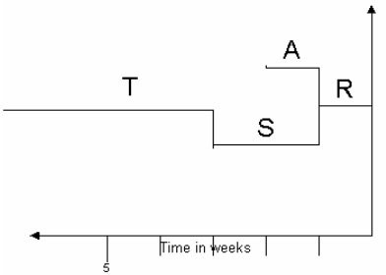

Bill of Material
Item |  |  | Quantity
R |  |  | 1
 | S(3) |  | 3
 |  | T(3) | 9
 | A(3) |  | 3

Diff: 2
Topic: MRP structure
AACSB: Analytic Skills
Objective: LO14-1
162) Each X requires 2 of component Y and 1 of part W. Each Y requires 10 of Z. Each W requires 3 of Q and 2 of R. Lead times are X = 1 week, Y = 1 week, W = 2 weeks, R = 1 week, Z = 3 weeks, and Q = 3 weeks.
a. Construct the time-phased product structure.
b. Construct the bill of material.
Answer: Solution:

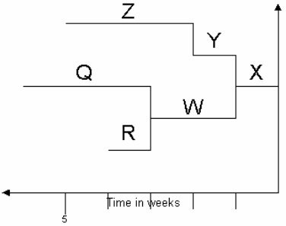

Bill of Material
Item |  |  | Quantity
X |  |  | 1
 | Y(2) |  | 2
 |  | Z(10) | 20
 | W(1) |  | 1
 |  | Q(3) | 3
 |  | R(2) | 2

Diff: 2
Topic: MRP structure
AACSB: Analytic Skills
Objective: LO14-1

163) A product has the following gross requirements. Which is cheaperlot-for-lot, part period balance, or EOQ lot sizing?

Week | 1 | 2 | 3 | 4 | 5 | 6
Requirements | 50 | 80 | 90 | 50 | 30 | 60

Other data for this scenario include: setup cost = $250, inventory holding cost $2 per unit per week. There is no beginning inventory; there are no scheduled receipts. The usage pattern is expected to continue for the remainder of the year.
Answer: Lot-for-lot will cost $250 x 6 = $1,500 for the six periods.

EOQ is based on 360/6 = 60 units per week average demand: 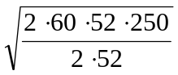= 122
Annual setup costs = 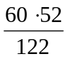 ∙ 250 + $6,393;
Annual holding costs = 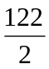∙ 2 ∙ 52 = $6,344
Total annual costs = $12,737; Cost for six weeks = 12,737 ∙ 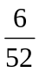 = $1,469
For part-period balancing, the EPP=250/2 = 125. Total cost for PPB over the six periods is $1,210.

Period | Order size | # of Units | CumPP | Setup cost | Holding cost
1 | 70 | 0 | 0
1, 2 | 150 | 80 | 80* | 250 | 160
1, 2, 3 | 240 | 90 * 2 | 260
3 | 90 | 0 | 0
3, 4 | 160 | 70 | 70
3, 4, 5 | 200 | 40 * 2 | 150* | 250 | 300
3, 4, 5, 6 | 270 | 70 * 3 | 360
6 | 70 | 0 | 0 | 250 | 0
 |  |  | Total | 750 | 460

Summary of costs: LFL = $1,500; EOQ = $1,469; PPB = $1,210. PPB is cheapest lot-sizing model for this problem.
Diff: 2
Topic: Lot-sizing techniques
AACSB: Analytic Skills
Objective: LO14-4

164) A product has the following gross requirements. Which is cheaper?lot-for-lot or EOQ lot-sizing?

Week | 1 | 2 | 3 | 4
Requirements | 50 | 30 | 40 | 80

Other data for this scenario include: setup cost = $1000, inventory holding cost $1 per unit per week. There is no beginning inventory; there are no scheduled receipts. The usage pattern is expected to continue for the remainder of the year.
Answer: Lot-for-lot will cost $1000 x 4 = $4,000 for the four periods.
EOQ is based on 200/4 = 50 units per week average demand: 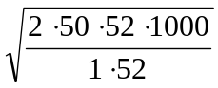= 316

Annual setup costs = 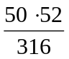 ∙ 1000 = $8,228;
Annual holding costs = 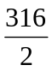 ∙ 1 ∙ 52 = $8,216
Total annual costs = $16,444; Cost for four weeks = 16,444 ∙ 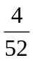 = $1,265
Summary of costs: LFL = $4,000; EOQ = $1,265. EOQ is cheaper lot-sizing model for this problem.
Diff: 2
Topic: Lot-sizing techniques
AACSB: Analytic Skills
Objective: LO14-4
165) Construct a product structure tree for a movie purchased in DVD format. Assume that it contains a single DVD disk. Don't be concerned with artwork?you may use labeled boxes for your parts and assemblies.
Answer: Not all DVDs are alike in their construction, so student answers will vary. Here is a fairly generic version. Note that the primary container is a one-piece molded plastic "clamshell." There are three layers, 0, 1, and 2.

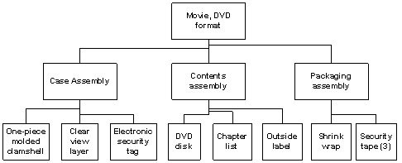
Diff: 2
Topic: Dependent inventory model requirements
AACSB: Analytic Skills
Objective: LO14-1

166) Construct an indented bill of material for a common 3-ring view binder (the kind that lets you slip your own cover sheet into the front panel and spine). Assume the rings to be 1 inch diameter. Don't worry about other dimensions?pay attention to accounting for all of the parts.
Answer: Not all such binders are identical, and student answers will vary, but here is a fairly generic version. The main components are the cover assembly and the ring assembly. Students will need to include some form of locking mechanism and/or spring.

Indented bill of material, Three-ring binder
Cover assembly
Front cover
Chipboard interior
Vinyl exterior, inside and outside of front cover
Clear "view" layer, outside
Vinyl pocket, inside
Spine
Chipboard interior
Vinyl exterior, inside and outside of front cover
Clear "view" layer, outside
Back cover
Chipboard interior
Vinyl exterior, inside and outside of front cover
Clear "view" layer, outside
Vinyl pocket, inside
Ring Assembly
Spine
Main spine (holds the three sets of rings and the tabs)
Spring (runs the length of the spine)
Rings (3)
Left ring half
Right ring half
Spacer and tensioner (2)
Clasps (2) (holds the locking tabs in)
Rivets (2)
Locking tabs (2)
Paperwork
Front insert
Spine insert
UPC tag
Diff: 2
Topic: Dependent inventory model requirements
AACSB: Analytic Skills
Objective: LO14-1

167) Jacquie Welkener, operations manager for ABC Technologies, must schedule work for the next five days. Each unit takes 30 minutes to process. Available capacity is 8 hours per day. The production order quantities are 12, 18, 20, 13, and 17 for Monday through Friday, respectively. What should be the production plan?
Answer: Sixteen units should be produced each day. Thus, 4 units should be moved from Tuesday to Monday, 2 units should be moved from Wednesday to Tuesday, 2 units should be moved from Wednesday to Thursday, and 1 unit should be moved from Friday to Thursday.
Diff: 1
Topic: Extensions of MRP
AACSB: Analytic Skills
Objective: LO14-5
168) Explode the following Bill of materials assuming 1 A is to be made. If there are 20 of every item except A in on-hand inventory how many As can be assembled?

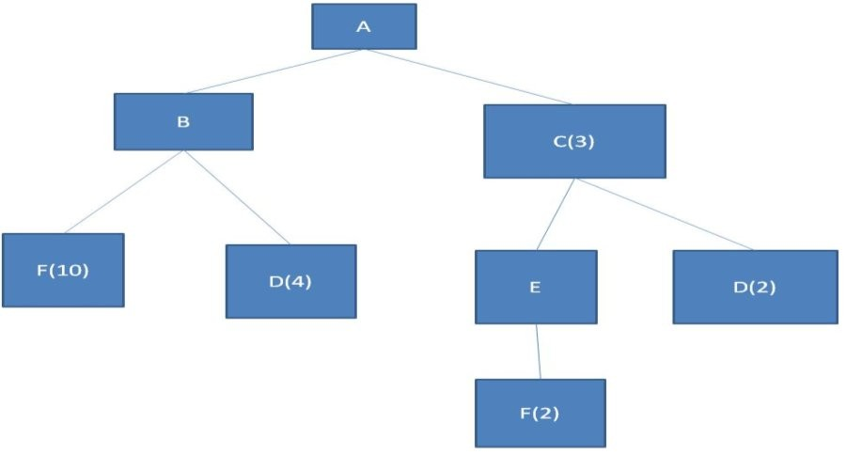
Answer:
Item A:1, Item B:1, Item C: 3 Item E: 3 Item D:2(3)+4(1)=10 Item F:2(3)+10=16
To find how many As can be constructed first consume all Bs and Cs to make 6As with 14 Bs left and 2Cs. Thus more Cs are needed. Consume 20Ds and 10 Es to make 10 addition Cs. Thus there are now 12 Cs and 14 Bs on hand, use these to produce 4 more As. This leaves 10 Bs, 20 Fs, and 10Es. Since no more Cs can be constructed no more As can be constructed. Thus the maximum number of A's that can be assembled is 6+4=10
Diff: 2
Topic: MRP structure
AACSB: Analytic Skills
Objective: LO14-1

169) Product A is made from 2 Bs and 1 C. Lead times for A, B, and C are 2, 3, and 2 weeks respectively. Currently there are 2 Bs and a 5 Cs on hand, with 5 of each scheduled to arrive at the end of week 1. If 20 As are needed during week 4, can the order be completed (it is the start of week 0 currently)?
Answer: To produce 20 As requires 40 Bs and 20 Cs at the start of week 2. Since the lead time for B is greater than 2 weeks the order cannot be completed on time.
Diff: 2
Topic: MRP structure
AACSB: Analytic Skills
Objective: LO14-3
170) A manufacturing company is trying to determine the cost of materials used to produce an A. If Fs cost $1 and Ds cost $2 how much does it cost to produce an A (in F and D materials only)?
Answer:
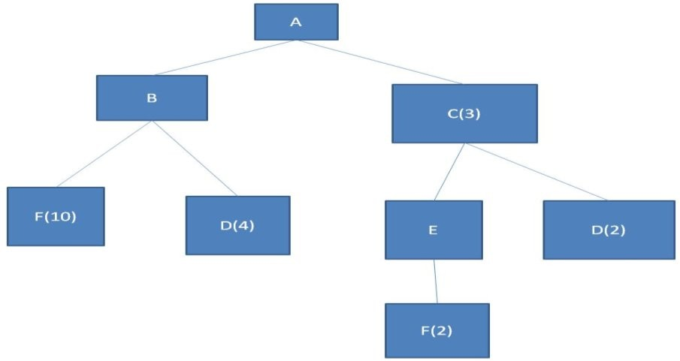

Using an explosion shows that 10 Ds and 16 Fs are needed to produce 1A. Thus the cost is 10($2)+16($1)= $36
Diff: 2
Topic: MRP structure
AACSB: Analytic Skills
Objective: LO14-1

171) Four A washers, Five B washers, Two C bolts, and a D bolt are required to make one Grill parts kit. If 100 grill part kits are needed how many more washers will be consumed than bolts?
Answer: Using MRP explosion gives A:400 B:500 C:200 D:100
Since A and B are washers and C and D are bolts the difference is 400+500-200-100 = 600 more washers are used than bolts
Diff: 2
Topic: MRP structure
AACSB: Analytic Skills
Objective: LO14-2
172) A company is trying to implement MRP but is having trouble determining which order sizing method will minimize costs. Setup cost is $200 and holding cost is $2/period. If each period is 1 week, gross requirements are 270 units per 10 weeks, and there are 6 planned order releases for every 10 weeks, calculate the cost for lot-for-lot compared to EOQ for an entire year. Assume that EOQ and lot-for-lot are computed as though the usage will occur continually throughout the year.
Answer: EOQ: D(yearly)=27/week*52 weeks = 1404 units
Using EOQ= sqrt (2DS/H) gives sqrt (2*1404*200/(2*52))= 73 units
Setups per year will be 1404/73 = 19, setup cost is 19*200=$3800
Holding cost is 73/2 * $2(52) = $3796
Setup+Holding=$7596 per year
Lot-for-lot: There is never any inventory in lot for lot, as it is consumed instantly. Thus cost is only set-up, or 6 setups * $200/setup = $1200/10 weeks = $120/week *52 weeks = $6240 per year.
Thus lot-for-lot is cheaper than EOQ for this scenario.
Diff: 2
Topic: Lot-sizing techniques
AACSB: Analytic Skills
Objective: LO14-4

